Spring boot2.0如何实现熔断监控Hystrix

1. 添加依赖

<dependency>  
 <groupId>org.springframework.cloud</groupId>  
 <artifactId>spring-cloud-starter-netflix-hystrix</artifactId>  
</dependency>  
<dependency>  
 <groupId>org.springframework.cloud</groupId>  
 <artifactId>spring-cloud-starter-netflix-hystrix-dashboard</artifactId>  
</dependency>  
<dependency>  
 <groupId>org.springframework.boot</groupId>  
 <artifactId>spring-boot-starter-actuator</artifactId>  
</dependency>

这三个依赖包必须添加

1. 启动类

启动类添加启用Hystrix Dashboard和熔断器

@EnableHystrixDashboard  
@EnableCircuitBreaker

例子如下：

@SpringBootApplication  
@EnableDiscoveryClient  
@EnableFeignClients  
@EnableHystrixDashboard  
@EnableCircuitBreaker  
**public class** DemoApplication {  
 **public static void** main(String[] args) {  
 SpringApplication.*run*(DemoApplication.**class**, args);  
 }  
 @Bean  
 **public** ServletRegistrationBean getServlet(){  
 HystrixMetricsStreamServlet streamServlet = **new** HystrixMetricsStreamServlet();  
 ServletRegistrationBean registrationBean = **new** ServletRegistrationBean(streamServlet);  
 registrationBean.setLoadOnStartup(1);  
 registrationBean.addUrlMappings(**"/actuator/hystrix.stream"**);  
 registrationBean.setName(**"HystrixMetricsStreamServlet"**);  
 **return** registrationBean;  
 }  
  
}

1. 项目启动项中配置Servlet

@Bean  
**public** ServletRegistrationBean getServlet(){  
 HystrixMetricsStreamServlet streamServlet = **new** HystrixMetricsStreamServlet();  
 ServletRegistrationBean registrationBean = **new** ServletRegistrationBean(streamServlet);  
 registrationBean.setLoadOnStartup(1);  
 registrationBean.addUrlMappings(**"/actuator/hystrix.stream"**);  
 registrationBean.setName(**"HystrixMetricsStreamServlet"**);  
 **return** registrationBean;  
}

1. 测试

启动工程后访问 http://localhost:9001/hystrix，将会看到如下界面：

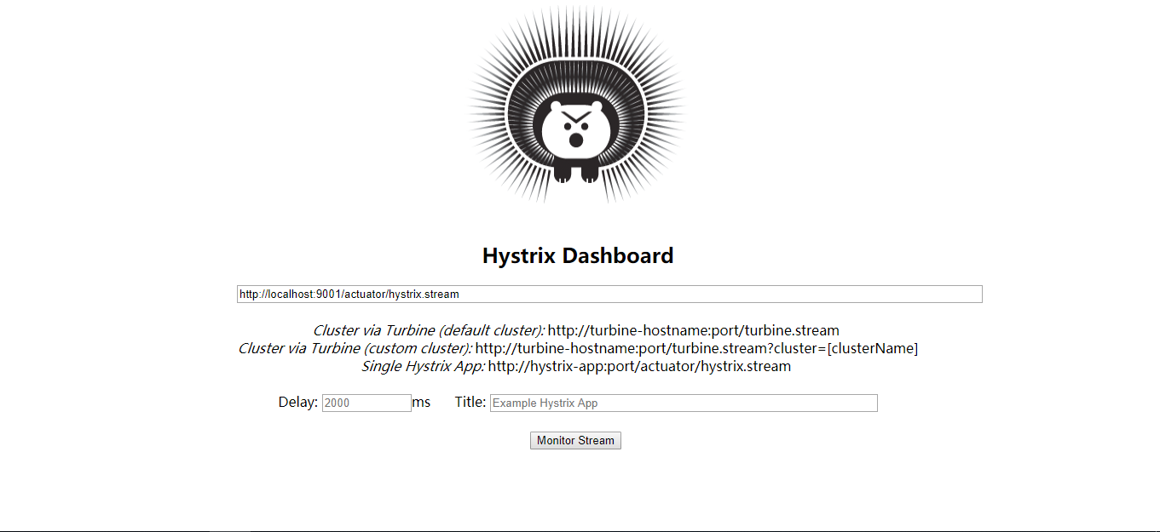

在输入框中输入http://localhost:9001/actuator/hystrix.stream

点击Monitor Stream

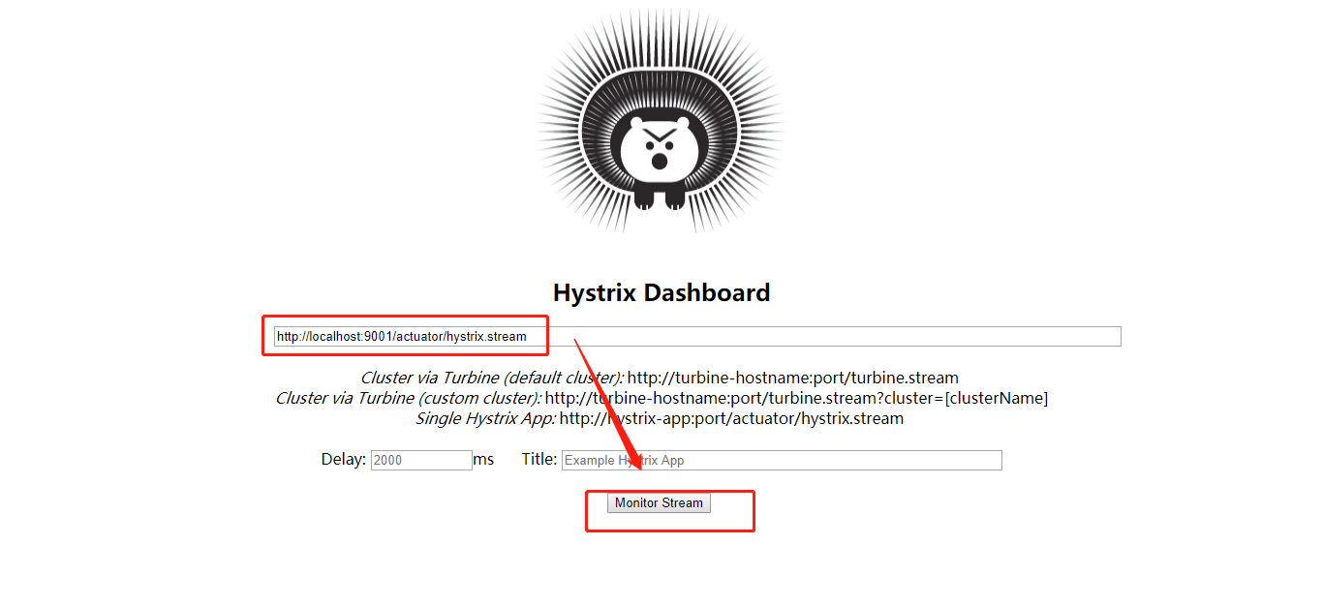

再在浏览器中进行访问：<http://localhost:9001/hello/neo>

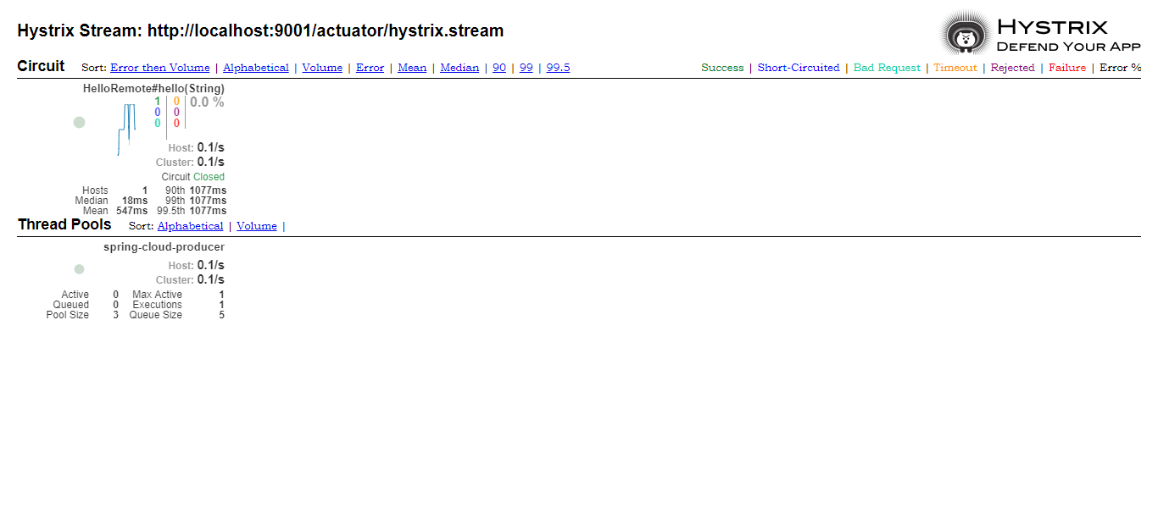

到此单个应用的熔断监控已经完成